**Enterprise Resource Planning**

**Training User Manual**

**VERSION 12.0.0**

**Sales & Invoice**

**Index**

|  |  |
| --- | --- |
| **About** | **Page No.** |
| * Challan Entry | **03** |
| * Challan Approve | **06** |
| * Bill/Invoice Entry | **08** |
| * Bill / Invoice Approve | **14** |
|  |  |
|  |  |

# [Challan Entry](http://192.168.1.17:8090/zab/login?screen=opdoheader&option=Invoice+Entry&menuname=op)

Header

|  |  |
| --- | --- |
| **Step 1** | Open System **>** Sales & Invoice **>** Challan Entry |
| **Step 2** | Write Customer ID , Store Code, Ref. , Attention, Date etc. |
| **Step 3** | Click **Add** |
| **Result** | New Challan header created |

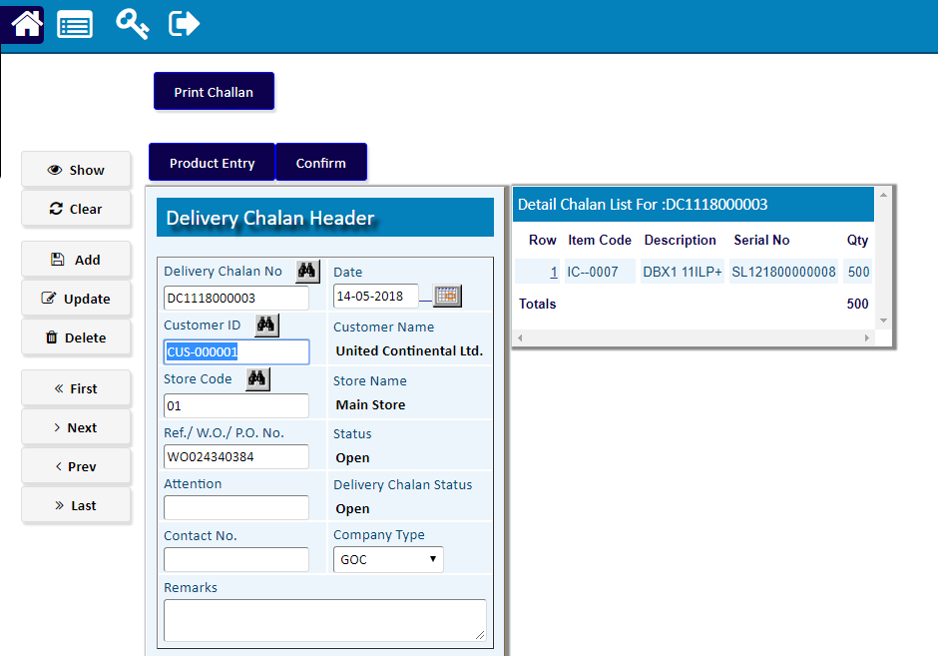

Detail

|  |  |
| --- | --- |
| **Step 1** | Click **Product Entry** |
| **Step 2** | Write Product ID , Quantity, Serial etc. |
| **Step 3** | Click **Add** |
| **Step 4** | Follow the Steps 2 & 3 to add mare Items. |
| **Step 5** | Click **Complete** to return Header. |

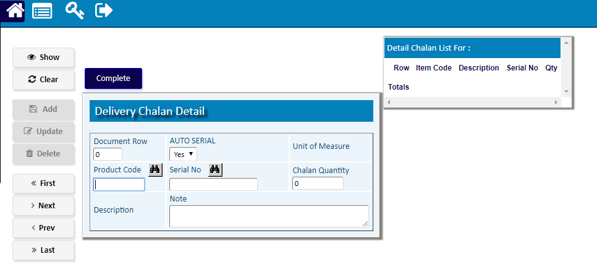

**) Click **Confirm** to Confirm the Challan

Challan Approver

|  |  |
| --- | --- |
| Step 1 | * Main Menu > Approver Notifications> [Challan Approver](http://192.168.1.2:8080/zab/login?screen=opdcheaderapp&option=Challan+Approver&menuname=notify) |
| **Step 2** | Pick a Challan from the Pending Challan Side list. |
| **Step 3** | Click **Approve** |
| **Result** | New Challan has been Approved |

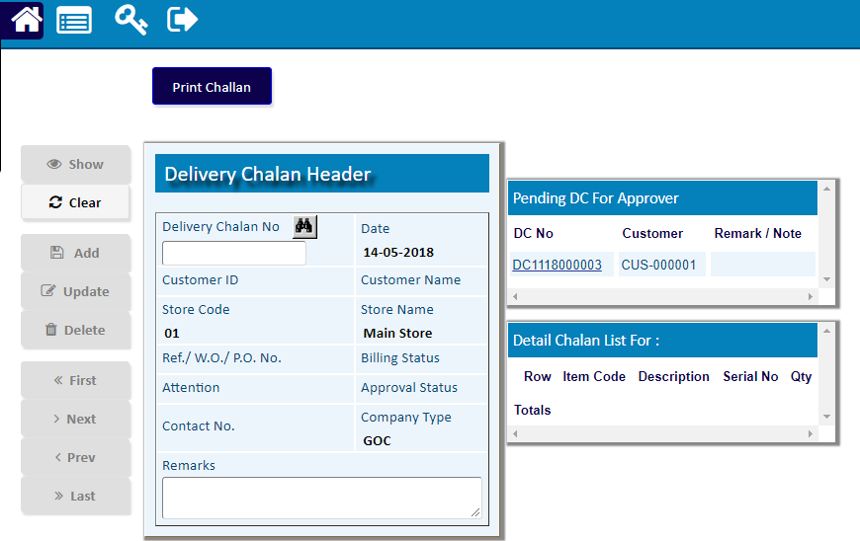

# Bill/[Invoice Entry](http://192.168.1.17:8090/zab/login?screen=opdoheader&option=Invoice+Entry&menuname=op)

## Invoice Header

|  |  |
| --- | --- |
| **Step 1** | Main Menu **>** Sales & Invoice **> Bill/**Invoice Entry |
| **Step 2** | Enter Customer Number and payment type , Ref. etc. |
| **Step 3** | Click **Add** |
| **Result** | New Invoice header created |

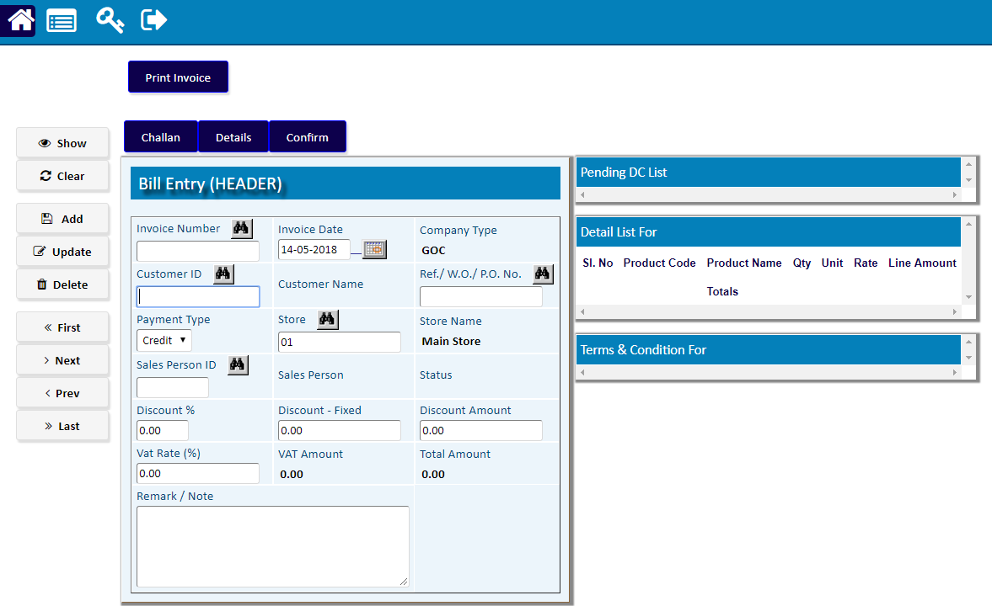

## Challan

|  |  |
| --- | --- |
| **Step 1** | Click **Challan** |
|  |  |
| **Step 2** | Pick the desired Challan from the side list of **Pending Challan** |
| **Step 4** | Click **Add** ; then Click **Confirm** |
| **Step 6** | Click **Complete** to return to Invoice header |

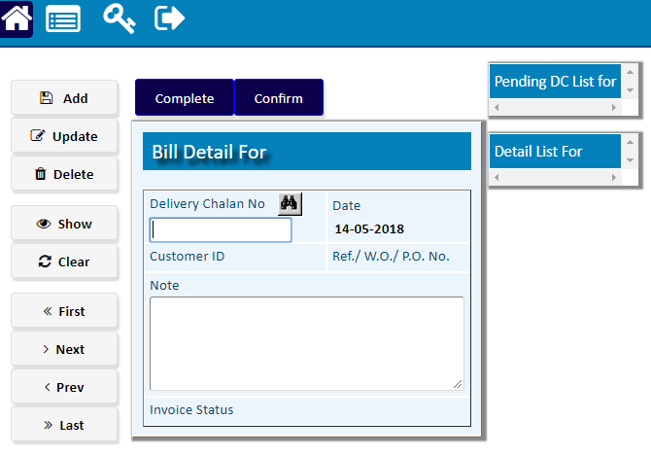

## Bill/Invoice Detail

|  |  |
| --- | --- |
| **Step 1** | Click on any row of side list of **Product Detail** |
| **Step 2** | Modify the Detail info if required. |
| **Step 3** | Click **Update** |
| **Result** | The Product Detail of the Invoice will be updated |

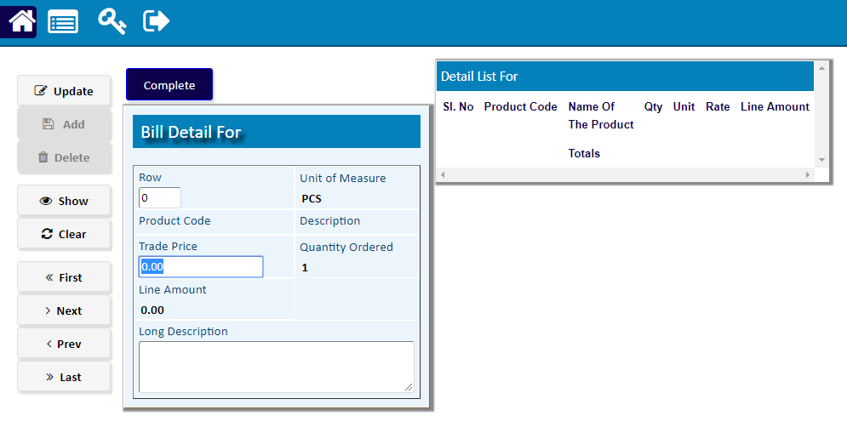

|  |  |
| --- | --- |
| **Step 7** | Click **Confirm** to confirm the Invoice. |
| **Note** | Invoice cannot be changed after confirmation. |
| **Result** | Invoice creation complete |

Bill/ Invoice Approver

|  |  |
| --- | --- |
| Step 1 | * Main Menu > Approver Notifications>  [Bill Approver](http://192.168.1.2:8080/zab/login?screen=opdcheaderapp&option=Challan+Approver&menuname=notify) |
| **Step 2** | Pick a Challan from the Pending Challan Side list. |
| **Step 3** | Click **Add** |
| **Result** | New Challan has been Approved  Click **Print Invoice** to Print the completed Bill |

